AI Practical: 08

AIM: Write a prolog program for the following:

1. Calculate the length of the list.
2. Check if the given list is sorted.

# Theory:

1. Length Calculation

This is used to find the length of list L. We will define one predicate to do this task. Suppose the predicate name is **list_length(L,N)**. This takes L and N as input argument. This will count the elements in a list L and instantiate N to their number. As was the case with our previous relations involving lists, it is useful to consider two cases −

* + If list is empty, then length is 0.
  + If the list is not empty, then L = [Head|Tail], then its length is 1 + length of Tail.

Program:

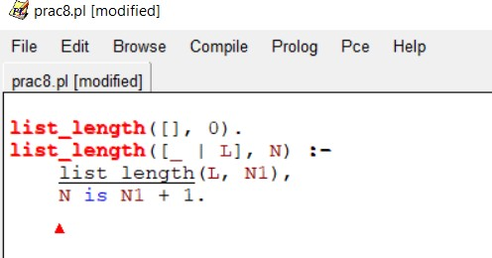

Output:

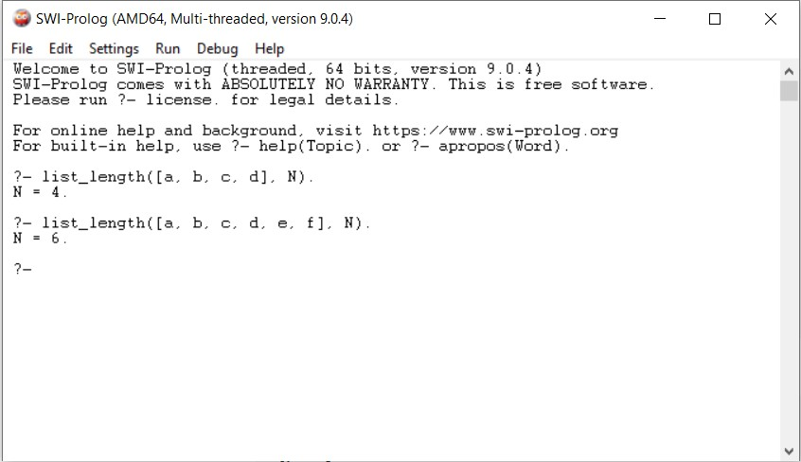

1. Sorted Order Operation

Here we will define a predicate list_order(L) which checks whether L is ordered or not. So if L = [1,2,3,4,5,6], then the result will be true.

* + If there is only one element, that is already ordered.
  + Otherwise take first two elements X and Y as Head, and rest as Tail. If X =< Y, then call the clause again with the parameter [Y|Tail], so this will recursively check from the next element.

Program:

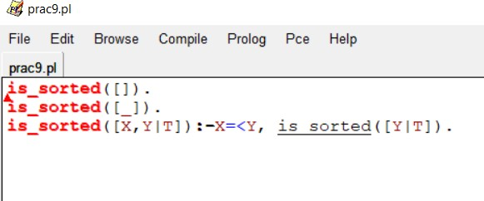

Output:

